# Overview

Call of Duty : Mobile (CODM) is a both PVP and PVE modes FPS game licensed by Activision and developed by TiMi J3 studio, released on Android and iOS. In CODM China version (CODMCN), it added two ways to play: cloud gaming and emulators. Same to the origin COD series, players need play as a soldier and using many of weapons to defeat the enemies.

This game is mainly focus on shooting on mobile devices. With this purpose, it keeps many of controlling action from origin COD like running and slide on floor. Tutorials in this game has been changed more comfortably for teaching more players have not played this game ever. For it’s thinking of “Giving game to more player“, game’s controlling isn’t very complicated. Attributing to both sence of firing and playable makes it to being awarded like “Mobile of the Year“.

**Developers:** TiMi J3 studio

**Platform:** Android, iOS

**Release Date:** October 1, 2019 (Worldwide, released by Actvision & South Asia, released by Garena); December 25, 2020 (China, released by Tencent).

**App Store Rating:** 4.3 stars (China)

**Genre:** FPS

**Awards:** Best Mobile Game of the Year (The Game Awards 2019)

# Controller Layouts

As a mobile game, it’s worth to assuming players can only using screen to play, and it’s necessary to make all the operations smoothly.

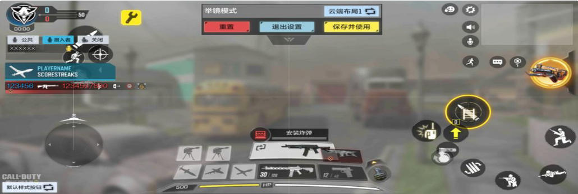

## A default screen controller layout

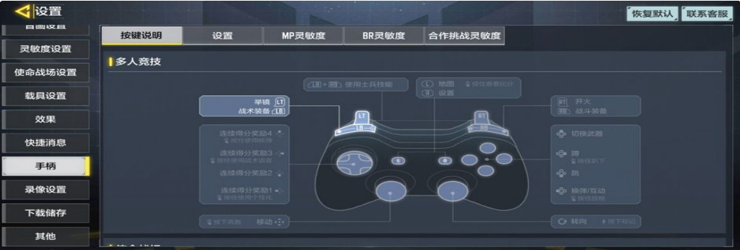

**A default xbox controller layout**

Because CODM is a mobile game and most of the players will play it only on screen, we will focus on printscreen controller layout mainly.

As a FPS game with many of actions inherited from COD, there’s some old problems we need resolve:

1. Many of buttons will block player’s viewing.
2. It’s hard to do some actions with mutiple buttons (like sliding).
3. There’s not have a task to define how and when a button displayed or not.

To deal with the controlling problems, we need try to analysis how the screen we will divided:

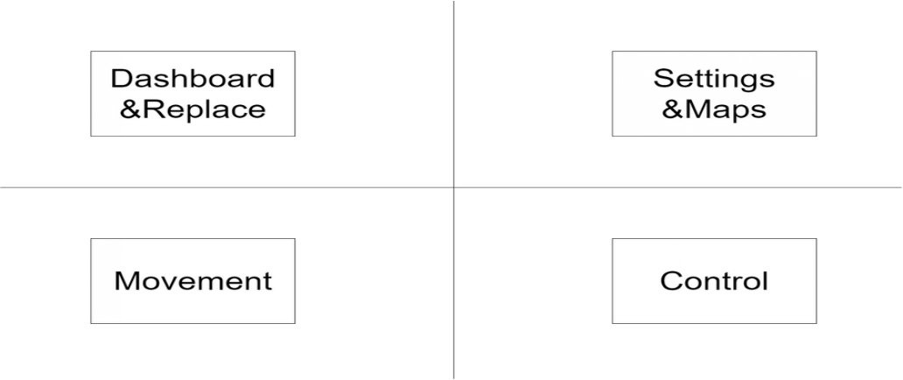

divided into 4 parts

With this aiming has been done, now we have a big plan: **What button is our Must-Have and what isn’t?**

Dashboard & Replace: Score, Kill Record, and some basic replace button for firing. Settings & Maps: Settings, Maps, and some buttons to convenient for chatting.

Movement: Moving controller. Control: Firing, aiming and actions.

Here’s some add-ons for the function parts above:

**Replace:** for the player who is worry to kill people but not hovering the Control position on time.

**Buttons for chatting:** Such as texting (Not easy to write in a fast paced competition).

**Moving controller:** Here’s two classic controller to use:

1. Direction Wheel. It’s easy to move the character with just sliding the screen. But can not offer a fine opreation.
2. Direction Keys. Hard to use for new players, but enough fine like stop to move.

For “bring game to more players“, CODM choosed the first moving controller.

**Actions:** Running, Squatting and Geting down.

After everything before has been done, there’s still some quesions living:

1. Where to switch the weapons?
2. In COD, we have Continuous Kill Reward System. Where to place these many of rewards?

For sure, left & right screen could not including too much buttons (for player’s viewing). Above the screen shows the same. So, we have to sacrifice below the screen’s space. Life bar and Weapons shared the same space.

# Player Interactions

This space contained about Movement. A CODM special method.

All the controlling methods should created for a fluently FPS experience.

Most like COD, CODM do not need to “find a ammo box“, but to swap a weapon.

There’s two weapons a player can carry. A main weapon and a sub-weapon. What will a player do with a low-ammo’s main weapon?

**Switch** to sub-weapon

**Pick up** a new one

In COD’s game design, switch weapon is always faster than reload, right? the switch action costs less times than reload. But when the time player’s sub-weapon carried a knife, he has to pick up a weapon with ammo. From here, the player interactions has to be done.

The player interactions not only contained the pick up weapons but also include some action others. For **reducing player’s controlling difficulty**, some of actions could be done in the same time.

Dashing to a door and it will be auto opened is a good choice. Running is a function players usually using, a door can block player’s viewing, and the time player’s close to open it there will be a chance for a battle face to face. As a balance method, stand up to open the door will keep accurancy, dash to the door will auto open it but the accurancy will be reduced with character’s hands actions.

# Gun Fight

Except all the COD style functions, CODM is a FPS game. All the operations should be a plus services behind the core gameplay. With FPS gameplay, here’s the things Must-Have:

An avatar Ranged weapons Enemies

With 3C —— character, control, and carema, avatar plays a role in character, and uses the weapons with player’s controller. Besides, all the actions need move camera for players to see it.

Here comes the core play experience —— **Dynamic Firefights.** The center point of CODM.

Not like Counter Strike, players do not need fire with standing up. Both slowly moving for aiming and keep moving and firing are allowed by COD’s shooting rules. The accurary of COD weapons is not limited so strict like CS.

Here’s another core play experience —— **Various Weapons.**

In CODM, players do not need always share the same weapons with the same parameters to others. The CODM teams keeps a wide range of balance for the weapons. Thanks to many types of weapons and the gunsmith system, everyone playing CODM could use the weapon set created by himself. For the gamer who never played COD on mobile platform, this is a new challenge. To begin with a nice weapon set, the player also need to searching online. In that case, the conmunication’s influence power will be stronger.

# Game Mode

CODM, a **FPS** designed specifically for **multiplayer gaming**, have a variety of **different styles** of match.

1. Multiplayer
2. Battle Royale
3. Zombies

In Multiplayer, the classic types are: Frontline

Team Deathmatch Domination Search & Destroy Free for All

Kill Confirmed Gunfight

From another place, CODM released as **free-to-play** as their intended business model and can be highly profitable. Some player communities complain about freemium first-person-shooters, fearing that they create unbalanced games, but many game designers have tweaked prices in response to criticism, and players can usually get the same benefits by playing longer rather than paying. Such as Battle Pass.

# Scorestreak

Scorestreak, as the next gen of Killstreak, deployed on CODM.

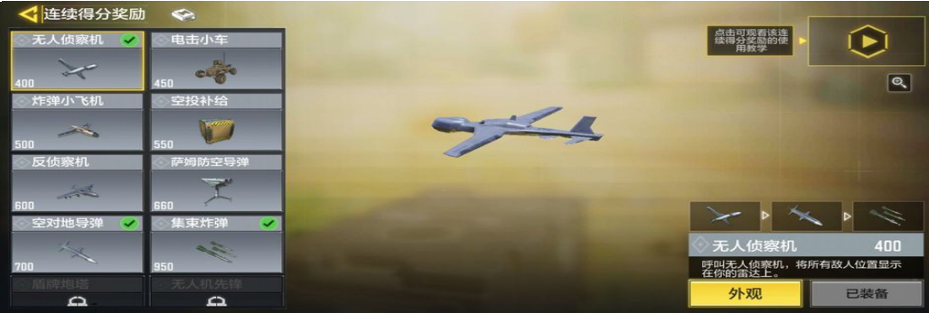

Scorestreak in CODM

So why CODM need to has such a system?

In a fast paced competition, sometimes players will killed by enemies by only one headshot. Detecting an enemy in this game is not too easy to do and do not even to say kill him. With this high risk background, CODM need to develop a function gives the player brave to kill the enemies but not squat down and ready for killing a unlucky guy.

You can not double his scores. that’s meaningless. Players who already prepared to play such a FPS game is not very focus on there KDA displayed (excepted always dead man). They’re usually care about how can they defeat the enemies.

Add player’s attributes after killing is also not a good design. What attribute can CODM add it? HP, ammo, or even dmg? What condition can make it being triggered? As a PVP Balance game, plus a player’s attributes is unacceptable.

But in another opinoion. If there’s a limit for plus the chance to kill enemies —— Not 100% useful for killing enemies, there’s still has chance for missing —— and with a hard-to-do condition, it is not such unaccpetable.

From now, the Scorestreak displayed it’s meaning.

There has three steps for Scorestreak: Easy

Medium Hard

These steps' condition is “easy“ to finish: just need kill the enemies or get enough scores. As rewards, there’re many of harmful and useful skills. Like killing four enemies for a drone can display the enemies' position per second. Sound so easy;)

But look at the key design: It can only counts in a signle life. When player’s dead, the count return to zero.

It means all the players need hurry to kill the enemies rather than stay away from battle field. It gives players an information that if you kill the enemies more you will get stronger.

Above all, Scorestreak inspired player’s confidence to fight. That’s a good design for playable. But CODM still need balance the new system and design many of new skills (not always the same as COD).

# Gunsmith

The Gunsmith is a feature in CODM. It allows the player to **customize**, **view** and **build out** their weapons incredibly precisely, as well as select multiple attachments and optics.

Gunsmith functions much in the same way it does in Modern Warfare II. Players still gain Weapon XP to unlock attachments for a specific weapon and its associated Weapons Platform, in addition to gaining alternative progression routes at launch. You can choose from familiar attachment options like the Barrel, Muzzle, Magazine, Optic, Laser, Rear Grip and more to create the optimal version of each weapon, depending on your playstyle.

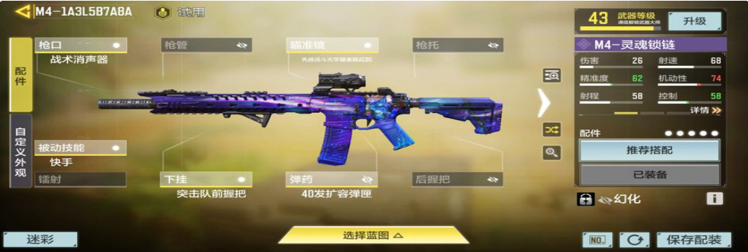

a case of gunsmith on M4 assult

**Attachment Unlocks:** For CODM weapons, attachments such as Grips, Barrels, Magazines, and Stocks will require players to use a specific weapon after they’ve already been unlocked for another one. For example, the M4 Assault Stock attachment is available for both the 4x Optic (at Level 55) and the 1x Optic (at Level 46). If your M4 is already progressed to Level 55 or higher, the mods will be available above.

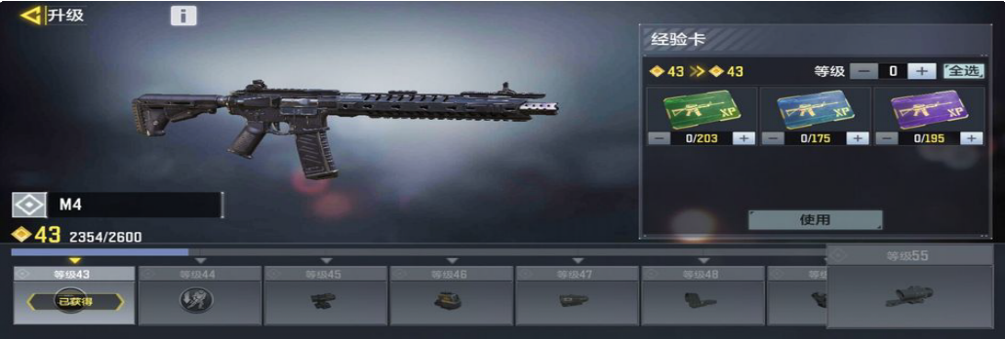

level limited

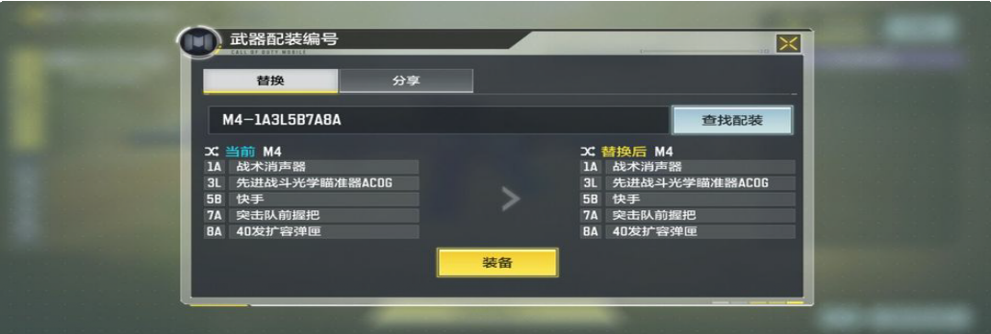

sharing equipped attachment to others

# Skill

Operator Skills is a special talent every player could change and carry in bags. With get scores enough, the Operator Skill could use, and it always easy to kill the enemies than normal weapons. When player dead, the operator skill return to disabled.

Here’s the operator skills in CODM: Annihilator

Ballista EM3 Ballistic Shield Barricade

Bull Charge Claw

Death Machine Equalizer (weapon) Gravity Spikes Gravity Vortex Gun H.I.V.E.

K9-Unit Kinetic Armor

Medical Station MORS

Munitions Box Purifier Reactor Core Shadow Blade Sparrow

Tac-Deploy TAK-5

Tempest Tracker Rifle War Machine

# Weapons

This space contained Various Attack Methods.

|  |  |
| --- | --- |
| Weapons of ***Call of Duty: Mobile*** | |
| [**Assault Rifles**](https://callofduty.fandom.com/wiki/Assault_Rifle) | [M4](https://callofduty.fandom.com/wiki/M4A1) **·** [AK117](https://callofduty.fandom.com/wiki/AK117) **·** [AK-47](https://callofduty.fandom.com/wiki/AK-47) **·** [Type 25](https://callofduty.fandom.com/wiki/Type_25) **·** [ASM10](https://callofduty.fandom.com/wiki/AN-94) **·** [BK57](https://callofduty.fandom.com/wiki/AKBP) **·** [LK24](https://callofduty.fandom.com/wiki/G37H) **·** [M16](https://callofduty.fandom.com/wiki/M16) **·** [ICR-](https://callofduty.fandom.com/wiki/ICR-1)  [1](https://callofduty.fandom.com/wiki/ICR-1) *(Season 2)* **·** [Man-O-War](https://callofduty.fandom.com/wiki/Man-O-War) *(Season 2)* **·** [HBRa3](https://callofduty.fandom.com/wiki/HBRa3) *(Season 3)* **·** [KN-](https://callofduty.fandom.com/wiki/KN-44)  [44](https://callofduty.fandom.com/wiki/KN-44) *(Season 4)* **·** [HVK-30](https://callofduty.fandom.com/wiki/HVK-30) *(Season 5)* **·** [DR-H](https://callofduty.fandom.com/wiki/SCAR-H) *(Season 8)* **·**  [Peacekeeper MK2](https://callofduty.fandom.com/wiki/Peacekeeper_MK2) *(Season 13)* **·** [FR .556](https://callofduty.fandom.com/wiki/FAMAS) *(2021 Season 1)* **·** [AS](https://callofduty.fandom.com/wiki/AS_VAL)  [VAL](https://callofduty.fandom.com/wiki/AS_VAL) *(2021 Season 2)* **·** [CR-56 AMAX](https://callofduty.fandom.com/wiki/CR-56_AMAX) *(2021 Season 5)* **·** [M13](https://callofduty.fandom.com/wiki/M13)  *(2021 Season 8)* **·** [Swordfish](https://callofduty.fandom.com/wiki/Swordfish) *(2021 Season 9)* **·** [Kilo 141](https://callofduty.fandom.com/wiki/Kilo_141) *(2022*  *Season 1)* **·** [Oden](https://callofduty.fandom.com/wiki/Oden) *(2022 Season 5)* **·** [Krig 6](https://callofduty.fandom.com/wiki/Krig_6) *(2022 Season 9)* **·**  [EM2](https://callofduty.fandom.com/wiki/EM2) *(2022 Season 11)* **·** [Maddox](https://callofduty.fandom.com/wiki/Maddox_RFB) *(2023 Season 2)* **·** [FFAR 1](https://callofduty.fandom.com/wiki/FFAR)  *(2023 Season 5)* **·** [Grau 5.56](https://callofduty.fandom.com/wiki/Grau_5.56) *(2023 Season 6)* **·** [Groza](https://callofduty.fandom.com/wiki/Groza) *(2023*  *Season 11)* |
| [**Sniper Rifles**](https://callofduty.fandom.com/wiki/Sniper_Rifle) | [DL Q33](https://callofduty.fandom.com/wiki/DL_Q33) **·** [M21 EBR](https://callofduty.fandom.com/wiki/M14_EBR) **·** [Arctic .50](https://callofduty.fandom.com/wiki/AS50) **·** [XPR-50](https://callofduty.fandom.com/wiki/XPR-50) **·** [Locus](https://callofduty.fandom.com/wiki/Locus) *(Season 2)* **·** [Outlaw](https://callofduty.fandom.com/wiki/Outlaw_(weapon)) *(Season 6)* **·** [NA-45](https://callofduty.fandom.com/wiki/NA-45) *(Season 11)* **·** [Rytec AMR](https://callofduty.fandom.com/wiki/Rytec_AMR) *(2021 Season 6)* **·** [SVD](https://callofduty.fandom.com/wiki/Dragunov) *(2021 Season 10)* **·** [Koshka](https://callofduty.fandom.com/wiki/Koshka) *(2022 Season 4)* **·**  [ZRG 20mm](https://callofduty.fandom.com/wiki/ZRG_20mm) *(2022 Season 8)* **·** [HDR](https://callofduty.fandom.com/wiki/HDR) *(2023 Season 3)* |
| [**Light Machine Guns**](https://callofduty.fandom.com/wiki/Light_Machine_Gun) | [RPD](https://callofduty.fandom.com/wiki/RPD) **·** [M4LMG](https://callofduty.fandom.com/wiki/M4LMG) **·** [UL736](https://callofduty.fandom.com/wiki/L86_LSW) **·** [S36](https://callofduty.fandom.com/wiki/QBB_LSW) **·** [Chopper](https://callofduty.fandom.com/wiki/Chain_SAW) *(Season 7)* **·** [Holger 26](https://callofduty.fandom.com/wiki/MG36)  *(2021 Season 4)* **·** [Hades](https://callofduty.fandom.com/wiki/Hades_(light_machine_gun)) *(2021 Season 7)* **·** [PKM](https://callofduty.fandom.com/wiki/PKM) *(2021 Season*  *11)* **·** [Dingo](https://callofduty.fandom.com/wiki/Dingo) *(2023 Season 1)* **·** [Bruen MK9](https://callofduty.fandom.com/wiki/M249_SAW) *(2023 Season 10)* |
| [**Submachine Guns**](https://callofduty.fandom.com/wiki/Submachine_Gun) | [RUS-79U](https://callofduty.fandom.com/wiki/AK-74u) **·** [PDW-57](https://callofduty.fandom.com/wiki/PDW-57) **·** [HG 40](https://callofduty.fandom.com/wiki/HG_40) **·** [Chicom](https://callofduty.fandom.com/wiki/Chicom_CQB) **·** [MSMC](https://callofduty.fandom.com/wiki/MSMC) **·** [Razorback](https://callofduty.fandom.com/wiki/Razorback) *(Season 2)* **·** [Pharo](https://callofduty.fandom.com/wiki/Pharo) *(Season 2)* **·** [GKS](https://callofduty.fandom.com/wiki/GKS) *(Season 5)* **·** [Cordite](https://callofduty.fandom.com/wiki/Cordite) *(Season 6)* **·** [QQ9](https://callofduty.fandom.com/wiki/MP5) *(Season 7)* **·** [Fennec](https://callofduty.fandom.com/wiki/Vector) *(Season 11)* **·** [AGR 556](https://callofduty.fandom.com/wiki/AUG_(submachine_gun))  *(Season 12)* **·** [QXR](https://callofduty.fandom.com/wiki/MP7) *(Season 13)* **·** [PP19 Bizon](https://callofduty.fandom.com/wiki/Bizon) *(2021 Season 3)* **·**  [MX9](https://callofduty.fandom.com/wiki/MX9) *(2021 Season 6)* **·** [CBR4](https://callofduty.fandom.com/wiki/P90) *(2021 Season 10)* **·** [PPSh-41](https://callofduty.fandom.com/wiki/PPSh-41) *(2022*  *Season 1)* **·** [MAC-10](https://callofduty.fandom.com/wiki/MAC-10) *(2022 Season 3)* **·** [KSP 45](https://callofduty.fandom.com/wiki/KSP_45) *(2022 Season 6)* **·**  [Switchblade X9](https://callofduty.fandom.com/wiki/Switchblade_X9) *(2022 Season 7)* **·** [LAPA](https://callofduty.fandom.com/wiki/LAPA) *(2022 Season 10)* **·** [OTs](https://callofduty.fandom.com/wiki/Kiparis)  [9](https://callofduty.fandom.com/wiki/Kiparis) *(2023 Season 4)* **·** [Striker 45](https://callofduty.fandom.com/wiki/Striker_45) *(2023 Season 7)* **·** [CX-9](https://callofduty.fandom.com/wiki/Skorpion_EVO) *(2023*  *Season 9)* |
| [**Shotguns**](https://callofduty.fandom.com/wiki/Shotgun) | [BY15](https://callofduty.fandom.com/wiki/W1200) **·** [Striker](https://callofduty.fandom.com/wiki/Striker) **·** [HS2126](https://callofduty.fandom.com/wiki/M1216) **·** [HS0405](https://callofduty.fandom.com/wiki/Model_1887) **·** [KRM-262](https://callofduty.fandom.com/wiki/KRM-262) *(Season 3)* **·** [Echo](https://callofduty.fandom.com/wiki/Origin_12_Shotgun)  *(Season 10)* **·** [R9-0](https://callofduty.fandom.com/wiki/R9-0_Shotgun) *(2021 Season 8)* **·** [JAK-12](https://callofduty.fandom.com/wiki/AA-12) *(2022 Season 2)* **·**  [Argus](https://callofduty.fandom.com/wiki/Argus) *(2023 Season 8)* |
| [**Marksman Rifles**](https://callofduty.fandom.com/wiki/Marksman_Rifle) | [Kilo Bolt-Action](https://callofduty.fandom.com/wiki/Kar98k) *(Season 9)* **·** [SKS](https://callofduty.fandom.com/wiki/SKS) *(2021 Season 1)* **·** [SP-R 208](https://callofduty.fandom.com/wiki/SP-R_208)  *(2021 Season 2)* **·** [MK2](https://callofduty.fandom.com/wiki/MK2_Carbine) *(2021 Season 4)* |
| [**Pistols**](https://callofduty.fandom.com/wiki/Handgun) | [MW11](https://callofduty.fandom.com/wiki/M1911) **·** [J358](https://callofduty.fandom.com/wiki/.357_Magnum) **·** [.50 GS](https://callofduty.fandom.com/wiki/Desert_Eagle) *(Season 12)* **·** [Renetti](https://callofduty.fandom.com/wiki/Renetti) *(2021 Season 3)* **·**  [Shorty](https://callofduty.fandom.com/wiki/725) *(2021 Season 5)* **·** [Crossbow](https://callofduty.fandom.com/wiki/Crossbow) *(2021 Season 7)* **·** [L-CAR 9](https://callofduty.fandom.com/wiki/L-CAR_9)  *(2022 Season 6)* **·** [Dobvra](https://callofduty.fandom.com/wiki/Makarov_(weapon)) *(2023 Season 4)* **·** [Nail Gun](https://callofduty.fandom.com/wiki/Nail_Gun) *(2023*  *Season 10)* |
| [**Melee**](https://callofduty.fandom.com/wiki/Melee_Weapons) | [Base Melee](https://callofduty.fandom.com/wiki/Combat_Knife) ([*Karambit*](https://callofduty.fandom.com/wiki/Karambit_Knife) ***·*** [*Ice Axe*](https://callofduty.fandom.com/wiki/Ice_Axe) ***·*** [*Assault Knife*](https://callofduty.fandom.com/wiki/Bowie_Knife) ***·*** [*Sword*](https://callofduty.fandom.com/wiki/Sword)) **·** [Knife](https://callofduty.fandom.com/wiki/Knife) **·** [Axe](https://callofduty.fandom.com/wiki/Axe) *(Season 2)* **·** [Baseball Bat](https://callofduty.fandom.com/wiki/Baseball_Bat) *(Season 3)* **·** [Katana](https://callofduty.fandom.com/wiki/Katana) *(Season 6)* **·** [Shovel](https://callofduty.fandom.com/wiki/Shovel) *(2021 Season 2)* **·** [Sickle](https://callofduty.fandom.com/wiki/Sickle) *(2021 Season 4)* **·** [Wrench](https://callofduty.fandom.com/wiki/Wrench) *(2021*  *Season 6)* **·** [Machete](https://callofduty.fandom.com/wiki/Machete) *(2021 Season 6)* **·** [Prizefighters](https://callofduty.fandom.com/wiki/Prizefighters) *(2021*  *Season 7)* **·** [Nunchucks](https://callofduty.fandom.com/wiki/Nunchucks) *(2021 Season 10)* **·** [Kali Sticks](https://callofduty.fandom.com/wiki/Kali_Sticks) *(2022*  *Season 4)* **·** [Butterfly Knife](https://callofduty.fandom.com/wiki/Butterfly_Knife) *(2022 Season 8)* **·** [Sai](https://callofduty.fandom.com/wiki/Sai) *(2023 Season 8)*  **·** [Ballistic Knife](https://callofduty.fandom.com/wiki/Ballistic_Knife) *(2023 Season 11)* |

|  |  |
| --- | --- |
| [**Launchers**](https://callofduty.fandom.com/wiki/Launcher) | [SMRS](https://callofduty.fandom.com/wiki/AT4) **·** [FHJ-18](https://callofduty.fandom.com/wiki/FHJ-18_AA) **·** [Thumper](https://callofduty.fandom.com/wiki/Thumper_(weapon)) *(2021 Season 9)* **·** [D13 Sector](https://callofduty.fandom.com/wiki/D13_Sector) *(2021 Season 11)* |
| [**Operator Skills**](https://callofduty.fandom.com/wiki/Operator_Skill) | [Purifier](https://callofduty.fandom.com/wiki/Purifier) **·** [Death Machine](https://callofduty.fandom.com/wiki/Death_Machine) **·** [War Machine](https://callofduty.fandom.com/wiki/War_Machine) **·** [Tempest](https://callofduty.fandom.com/wiki/Tempest) **·** [Transform](https://callofduty.fandom.com/wiki/Barricade) [Shield](https://callofduty.fandom.com/wiki/Barricade) **·** [Sparrow](https://callofduty.fandom.com/wiki/Sparrow) **·** [Gravity Spikes](https://callofduty.fandom.com/wiki/Gravity_Spikes) *(Season 2)* **·** [H.I.V.E.](https://callofduty.fandom.com/wiki/H.I.V.E) *(Season 4)*  **·** [Annihilator](https://callofduty.fandom.com/wiki/Annihilator) *(Season 6)* **·** [Shadow Blade](https://callofduty.fandom.com/wiki/Shadow_Blade) *(Season 8)* **·** [Equalizer](https://callofduty.fandom.com/wiki/Equalizer_(weapon)) *(Season 10)* **·** [Ballistic Shield](https://callofduty.fandom.com/wiki/Ballistic_Shield) *(Season 12)* **·** [Gravity Vortex Gun](https://callofduty.fandom.com/wiki/Gravity_Vortex_Gun) *(2021 Season 1)* **·** [Bull Charge](https://callofduty.fandom.com/wiki/Bull_Charge) *(2021 Season 3)* **·** [K9-Unit](https://callofduty.fandom.com/wiki/K9-Unit) *(2021*  *Season 5)* **·** [Kinetic Armor](https://callofduty.fandom.com/wiki/Kinetic_Armor) *(2021 Season 7)* **·** [TAK-5](https://callofduty.fandom.com/wiki/TAK-5) *(2021 Season*  *9)* **·** [Munitions Box](https://callofduty.fandom.com/wiki/Munitions_Box) *(2021 Season 11)* **·** [Reactor Core](https://callofduty.fandom.com/wiki/Reactor_Core) *(2022 Season 3)* **·** [Claw](https://callofduty.fandom.com/wiki/Claw) *(2022 Season 7)* **·** [Ballista EM3](https://callofduty.fandom.com/wiki/Ballista_EM3) *(2022 Season 10)* **·** [Tac-Deploy](https://callofduty.fandom.com/wiki/Tac-Deploy) *(2023 Season 7)* |
| [**Attachments**](https://callofduty.fandom.com/wiki/Attachment) | *Muzzle:* [OWC Light Suppressor](https://callofduty.fandom.com/wiki/Lightweight_Suppressor) **·** [Tactical Suppressor](https://callofduty.fandom.com/wiki/Tactical_Suppressor) **·** [Monolithic](https://callofduty.fandom.com/wiki/Monolithic_Suppressor) [Suppressor](https://callofduty.fandom.com/wiki/Monolithic_Suppressor) **·** [Colossus Suppressor](https://callofduty.fandom.com/wiki/Colossus_Suppressor) **·** [Agency Suppressor](https://callofduty.fandom.com/wiki/Agency_Suppressor) **·** [Marauder Suppressor](https://callofduty.fandom.com/wiki/FORGE_TAC_Marauder) **·** [Oil Can Suppressor](https://callofduty.fandom.com/wiki/Oil_Can_Suppressor) **·** [OWC Light](https://callofduty.fandom.com/wiki/Compensator) [Compensator](https://callofduty.fandom.com/wiki/Compensator) **·** RTC Compensator **·** [Infantry Compensator](https://callofduty.fandom.com/wiki/Infantry_Compensator) **·** RTC Muzzle Brake **·** [RTC Light Muzzle Brake](https://callofduty.fandom.com/wiki/Muzzle_Brake) **·** MIP Light Muzzle Brake   * [Flash Guard](https://callofduty.fandom.com/wiki/Flash_Guard) **·** MIP Flashguard **·** MIP Light Flash Guard **·** YKM Light Flash Guard **·** [Breacher Device](https://callofduty.fandom.com/wiki/Breacher_Device) **·** [OWC Eliminator](https://callofduty.fandom.com/wiki/SOCOM_Eliminator) **·** [Choke](https://callofduty.fandom.com/wiki/Choke)   *Barrel:* Various (YKM Integral Suppressor Light **·** YKM Integral Suppressor **·** [MIP Light Barrel (Short)](https://callofduty.fandom.com/wiki/MIP_Light_Barrel_(Short)) **·** [MIP Light](https://callofduty.fandom.com/wiki/MIP_Light) **·** [MIP Extended](https://callofduty.fandom.com/wiki/MIP_Extended_Light_Barrel) [Light Barrel](https://callofduty.fandom.com/wiki/MIP_Extended_Light_Barrel) **·** MIP Steady **·** OWC Ranger **·** [OWC Marksman](https://callofduty.fandom.com/wiki/OWC_Marksman) **·** RTC Extended Light Barrel **·** [Rapid Fire Barrel](https://callofduty.fandom.com/wiki/Rapid_Fire_(Barrel)) **·** Built-In Silence Barrel **·** Long-Range Barrel **·** [Sawed-Off Barrel](https://callofduty.fandom.com/wiki/Sawed-Off) **·** [Extended Barrel](https://callofduty.fandom.com/wiki/Long_Barrel) **·** Light Barrel (Long) **·** Light Barrel (Short) **·** [Taskforce Barrel](https://callofduty.fandom.com/wiki/Task_Force_(Barrel)) **·** [Reinforced](https://callofduty.fandom.com/wiki/Reinforced_Heavy_(Barrel)) [Heavy](https://callofduty.fandom.com/wiki/Reinforced_Heavy_(Barrel)) **·** [Cavalry Lancer](https://callofduty.fandom.com/wiki/Cavalry_Lancer_(Barrel)))  AK-47 only ([GRU Combo Grip](https://callofduty.fandom.com/wiki/GRU_Combo_Grip)) **·** ASM10 ([Branson](https://callofduty.fandom.com/wiki/Branson)) **·** HVK-30 ([YKM Integral Suppressor Heavy](https://callofduty.fandom.com/wiki/YKM_Integral_Suppressor_Heavy)) **·** Peacekeeper MK2 (Well- Forged Barrel) **·** AS VAL ([MIP Quick Response Barrel](https://callofduty.fandom.com/wiki/Stovl_SOF) **·** [MIP](https://callofduty.fandom.com/wiki/VLK_105mm_Sova) [105mm Melee Barrel](https://callofduty.fandom.com/wiki/VLK_105mm_Sova) **·** [MIP 200mm Mid-Range Barrel](https://callofduty.fandom.com/wiki/VLK_200mm_Osa)) **·** CR-56 AMAX ([Gunner Stock](https://callofduty.fandom.com/wiki/FSS_11.8%22_Squall) **·** [Intruder Stock](https://callofduty.fandom.com/wiki/FSS_8.3%22_Intruder) **·** [MIP Custom Long](https://callofduty.fandom.com/wiki/XRK_Zodiac_S440)) **·** M13 ([RTC Silencer Barrel](https://callofduty.fandom.com/wiki/Tempus_Cyclone) **·** [RTC Mini Barrel](https://callofduty.fandom.com/wiki/Tempus_Mini) **·** [RTC Heavy Long Barrel](https://callofduty.fandom.com/wiki/Tempus_Marksman))   * DL Q33 (.408 Standard **·** Free Floating) **·** M21 EBR (MIP Precise) * Arctic .50 (Assassin Short **·** 0.5 Light Long **·** Anti-Material Heavy **·** OWC Monolithic Suppressor) **·** XPR-50 (RTC Lightweight **·** RTC CQB **·** RTC Long) **·** Locus (YKM Lightweight Short **·** YKM Lightweight Long **·** [YKM Standard](https://callofduty.fandom.com/wiki/YKM_Standard)) **·** Outlaw (MIP Tac Long **·** MIP Memorial Cowboy) **·** NA-45 **·** (MIP Custom Light **·** RTC Modified **·** OWC Tac Long) **·** SVD ([RTC 660mm Heavy](https://callofduty.fandom.com/wiki/660mm_Extended_Barrel) **·** [RTC 510mm Light](https://callofduty.fandom.com/wiki/510mm_Compact_Barrel)) **·** RPD (OWC Heavy Barrel **·** OWC Compact Barrel **·** OWC Extended Barrel **·** [Cooling Compressor Barrel](https://callofduty.fandom.com/wiki/Cooling_Compressor_Barrel)) **·** M4LMG (MIP Ultralight Barrel **·** MIP Short Barrel) **·** UL736 (RTC 12.4" Light Barrel **·** RTC 18.2" Short **·** RTC 25.4" Extended Barrel) **·** S36 (Compagnie Generale Sevier - Light Barrel **·** Compagnie Generale Sevier - Short Barrel) **·** Chopper (Chopper Infantry **·** Chopper Special Forces **·** Chopper Heavy) **·** QQ9 (RTC Recon Tac Long **·** MIP Customized Light Barrel **·** MIP Tactical Barrel **·** [Monolithic](https://callofduty.fandom.com/wiki/Monolithic_Integral_Suppressor) [Integral Suppressor](https://callofduty.fandom.com/wiki/Monolithic_Integral_Suppressor)) **·** Striker (OWC Customized Heavy Barrel **·** [RTC Retractable Barrel](https://callofduty.fandom.com/wiki/RTC_Retractable_Barrel)) **·** HS2126 (YKM Light Barrel (Long) **·** YKM Light Barrel (Short) **·** YKM Heavy Barrel) **·** MK2 ([20.0 Forged](https://callofduty.fandom.com/wiki/FSS_20.0%22_Factory) |

[Barrel](https://callofduty.fandom.com/wiki/FSS_20.0%22_Factory) **·** [18.0 Sport Barrel](https://callofduty.fandom.com/wiki/FSS_18.0%22_Factory)) **·** MW11 (.45 Tac Long **·** .45 Suppressor Light **·** [.45 Compact](https://callofduty.fandom.com/wiki/.45_Compact)) **·** J358 (J358 Custom Light **·** J358 Long **·** J358 Short)

*Bowstring:* [16 Bowstring](https://callofduty.fandom.com/wiki/16-Strand_Cable) **·** [28 Bowstring](https://callofduty.fandom.com/wiki/28-Strand_Cable)

*Limb:* [Customized Limb](https://callofduty.fandom.com/wiki/XRK_Quill_100_Lb) **·** [Enhanced Limb](https://callofduty.fandom.com/wiki/XRK_Carbon_Elite) **·** [Heavy Limb](https://callofduty.fandom.com/wiki/XRK_Thunder_200_Lb)

*Optic:* [Classic Red Dot Sight](https://callofduty.fandom.com/wiki/Red_Dot_Sight) **·** [Red Dot Sight 1](https://callofduty.fandom.com/wiki/G.I._Mini_Reflex) **·** [Red Dot Sight 2](https://callofduty.fandom.com/wiki/Solozero_Optics_Mini_Reflex) **·** [Red Dot Sight 3](https://callofduty.fandom.com/wiki/Cronen_LP945_Mini_Reflex) **·** [Red Dot Sight 4](https://callofduty.fandom.com/wiki/Kobra_Red_Dot) **·** [Red Dot Sight 5](https://callofduty.fandom.com/wiki/Monocle_Reflex_Sight) **·** [Red Dot](https://callofduty.fandom.com/wiki/Operator_Reflex_Sight) [Sight 6](https://callofduty.fandom.com/wiki/Operator_Reflex_Sight) **·** [Classic Holographic Sight](https://callofduty.fandom.com/wiki/Classic_Holographic_Sight) **·** [Holographic Sight 1](https://callofduty.fandom.com/wiki/APX5_Holographic_Sight) **·** [Holographic Sight 2](https://callofduty.fandom.com/wiki/Holographic_Sight) **·** [Holographic Sight 3](https://callofduty.fandom.com/wiki/PBX_Holo_7_Sight) **·** [Tactical Scope](https://callofduty.fandom.com/wiki/Tactical_Scope) **·** [3X](https://callofduty.fandom.com/wiki/VLK_3.0x_Optic) [Tactical Scope 1](https://callofduty.fandom.com/wiki/VLK_3.0x_Optic) **·** [3X Tactical Scope 2](https://callofduty.fandom.com/wiki/Scout_Combat_Optic) **·** [3X Tactical Scope 3](https://callofduty.fandom.com/wiki/Cronen_C480_Pro_Optic) **·** [4X](https://callofduty.fandom.com/wiki/4x_Optic) [Tactical Scope](https://callofduty.fandom.com/wiki/4x_Optic) **·** [OWC 4.4X Tactical Scope](https://callofduty.fandom.com/wiki/OWC_4.4X_Tactical_Scope) **·** [RTC 4.4X Tactical](https://callofduty.fandom.com/wiki/Sniper_Scope) [Scope](https://callofduty.fandom.com/wiki/Sniper_Scope) **·** 6X Tactical Scope 2 **·** [6X Tactical Scope 3](https://callofduty.fandom.com/wiki/6x_Optic) **·** [Thermal](https://callofduty.fandom.com/wiki/Thermal_Scope) [Scope](https://callofduty.fandom.com/wiki/Thermal_Scope) *(BR only)*

*Stock:* Various ([YKM Light Stock](https://callofduty.fandom.com/wiki/YKM_Light_Stock) **·** [YKM Combat Stock](https://callofduty.fandom.com/wiki/YKM_Combat_Stock) **·** [MIP Strike](https://callofduty.fandom.com/wiki/MIP_Strike_Stock) [Stock](https://callofduty.fandom.com/wiki/MIP_Strike_Stock) **·** MIP Stalker Stock **·** RTC Steady Stock **·** OWC Skeleton Stock **·** OWC Ranger Stock **·** [Light Weight Stock](https://callofduty.fandom.com/wiki/Tactical_Stock) **·** [Marathon Stock](https://callofduty.fandom.com/wiki/Marathon_Stock)

* [Agile Stock](https://callofduty.fandom.com/wiki/Raider_Stock) **·** [No Stock](https://callofduty.fandom.com/wiki/No_Stock))

HBRa3 only ([Thunderbolt Sling](https://callofduty.fandom.com/wiki/Thunderbolt_Sling)) **·** CR-56 AMAX ([Psilos Light Stock](https://callofduty.fandom.com/wiki/CR-56_EXO)

**·** [MIP Gatekeeper](https://callofduty.fandom.com/wiki/XRK_Gatekeeper) **·** [Custom Strike](https://callofduty.fandom.com/wiki/FTAC_Spartan) **·** MIP Tracker Stock) **·** M13 ([M13 Skeleton Stock](https://callofduty.fandom.com/wiki/M13_Skeleton_Stock) **·** [RTC Combat Stock](https://callofduty.fandom.com/wiki/FSS_Close_Quarters_Stock) **·** [RTC Assault Tactical](https://callofduty.fandom.com/wiki/FORGE_TAC_Stalker))

* XPR-50 (YKM Ghost Stock) **·** MK2 ([MIP Sport Stock](https://callofduty.fandom.com/wiki/FSS_MK2_Sport_Comb) **·** [Custom](https://callofduty.fandom.com/wiki/FSS_MK2_Precision_Comb) [Accuracy Stock](https://callofduty.fandom.com/wiki/FSS_MK2_Precision_Comb) **·** [Cartridge Sleeve](https://callofduty.fandom.com/wiki/Cartridge_Sleeve) **·** [Ultralight Hollow](https://callofduty.fandom.com/wiki/MK2_Ultralight_Hollow)) **·** Renetti ([Folding Stock](https://callofduty.fandom.com/wiki/FTAC_SATUS_CS-3) **·** [Control](https://callofduty.fandom.com/wiki/FTAC_G-X) **·** [Combo](https://callofduty.fandom.com/wiki/FTAC_SATUS_CS-X)) **·** Crossbow ([Watcher Stock](https://callofduty.fandom.com/wiki/FORGE_TAC_Dart_CB) **·** [Ranger Stock](https://callofduty.fandom.com/wiki/FORGE_TAC_Apex) **·** [Archer Stock](https://callofduty.fandom.com/wiki/FORGE_TAC_SpeedTrak))

*Laser:* [RTC Laser 1mW](https://callofduty.fandom.com/wiki/1mW_Laser) **·** [1mW Steady Aim Laser](https://callofduty.fandom.com/wiki/Steady_Aim_Laser) **·** [MIP Laser](https://callofduty.fandom.com/wiki/5mW_Laser) [5mW](https://callofduty.fandom.com/wiki/5mW_Laser) **·** [5mW Combat Laser](https://callofduty.fandom.com/wiki/SWAT_5mw_Laser_Sight) **·** [OWC Laser - Tactical](https://callofduty.fandom.com/wiki/Tac_Laser) **·** Aim Assist Laser **·** YKM Laser - Ranger **·** RTC Laser - Merc **·** [Tactical](https://callofduty.fandom.com/wiki/Tactical_Flashlight) [Flashlight](https://callofduty.fandom.com/wiki/Tactical_Flashlight)

*Underbarrel:* [Foregrip](https://callofduty.fandom.com/wiki/Foregrip) **·** [Strike Foregrip](https://callofduty.fandom.com/wiki/Commando_Foregrip) **·** [Merc Foregrip](https://callofduty.fandom.com/wiki/Merc_Foregrip) **·** [Operator](https://callofduty.fandom.com/wiki/Operator_Foregrip) [Foregrip](https://callofduty.fandom.com/wiki/Operator_Foregrip) **·** [Ranger Foregrip](https://callofduty.fandom.com/wiki/Ranger_Foregrip) **·** [Tactical Foregrip A](https://callofduty.fandom.com/wiki/Angled_Grip) **·** Tactical Foregrip B **·** [Elite Foregrip](https://callofduty.fandom.com/wiki/Elite_Foregrip) **·** OWC Foregrip **·** [Infiltrator Foregrip](https://callofduty.fandom.com/wiki/Infiltrator_Grip) **·** [Patrol](https://callofduty.fandom.com/wiki/Patrol_Grip) [Foregrip](https://callofduty.fandom.com/wiki/Patrol_Grip) **·** [Field Agent Foregrip](https://callofduty.fandom.com/wiki/Field_Agent_Foregrip) **·** [SFOD Fast Foregrip](https://callofduty.fandom.com/wiki/SFOD_Speedgrip) **·** [Red Cell](https://callofduty.fandom.com/wiki/Red_Cell_Foregrip) [Foregrip](https://callofduty.fandom.com/wiki/Red_Cell_Foregrip) **·** [Striker Foregrip](https://callofduty.fandom.com/wiki/Bruiser_Grip) **·** [BO Foregrip](https://callofduty.fandom.com/wiki/Front_Grip) **·** Piranha Foregrip **·** [Quickdraw](https://callofduty.fandom.com/wiki/Quickdraw_Handle) **·** [Bipod](https://callofduty.fandom.com/wiki/Bipod) **·** [Heavy Handle](https://callofduty.fandom.com/wiki/XRK_ChainSAW) **·** [Crossbar](https://callofduty.fandom.com/wiki/Cross_Bar) **·** [Stippled Fore Grip](https://callofduty.fandom.com/wiki/Stippled_Grip_Tape_(underbarrel)) [Tape](https://callofduty.fandom.com/wiki/Stippled_Grip_Tape_(underbarrel)) **·** [Granulated Fore Grip Tape](https://callofduty.fandom.com/wiki/Granulated_Grip_Tape_(underbarrel)) **·** [Rubberized Fore Grip Tape](https://callofduty.fandom.com/wiki/Rubberized_Grip_Tape_(underbarrel)) **·** Tactical Guard **·** Steady Guard **·** [Underbarrel Stun Gun](https://callofduty.fandom.com/wiki/Underbarrel_Stun_Gun) **·** [Underbarrel Launcher](https://callofduty.fandom.com/wiki/M203) **·** [GRD-11](https://callofduty.fandom.com/wiki/GRD-11)

*Trigger Action:* [Match Grade Trigger](https://callofduty.fandom.com/wiki/Match_Grade_Trigger) **·** [Heavy Duty Trigger](https://callofduty.fandom.com/wiki/Heavy_Duty_Trigger) **·** [Lightweight Trigger](https://callofduty.fandom.com/wiki/Lightweight_Trigger) **·** [Heavyweight Double-Action](https://callofduty.fandom.com/wiki/Heavyweight_Double-Action) **·** [Lightweight](https://callofduty.fandom.com/wiki/Lightweight_Single-Action) [Single-Action](https://callofduty.fandom.com/wiki/Lightweight_Single-Action) **·** [Lightweight Double-Action](https://callofduty.fandom.com/wiki/Lightweight_Double-Action)

*Smoothbore:* [MFT Heavy Smoothbore](https://callofduty.fandom.com/wiki/FSS_R9-0_Bulldog) **·** [MFT Ultra Light](https://callofduty.fandom.com/wiki/FTAC_Ultralight_Pump) [Smoothbore](https://callofduty.fandom.com/wiki/FTAC_Ultralight_Pump) **·** [MFT Urban Combat](https://callofduty.fandom.com/wiki/FTAC_Close_Quarters_Pro)

*Guard:* [OWC Stable](https://callofduty.fandom.com/wiki/FORGE_TAC_Steady_Grip) **·** [OWC Commander](https://callofduty.fandom.com/wiki/FORGE_TAC_Commander) **·** [OWC Slim](https://callofduty.fandom.com/wiki/Tempus_SlimGrip)

*Bolt:* [Light Bolt](https://callofduty.fandom.com/wiki/Sloan_KR-600_Feather) **·** [Heavy Bolt](https://callofduty.fandom.com/wiki/Sloan_KR-800_DeadEye) **·** [Sticky Grenade Bolt](https://callofduty.fandom.com/wiki/Explosive_Tip) **·** [Thermite Bolt](https://callofduty.fandom.com/wiki/FTAC_Backburn_20%22_Bolts) **·**

[Gas Grenade Bolt](https://callofduty.fandom.com/wiki/FTAC_Venom_20%22_Bolts)

*Ammunition:* [Extended Mag](https://callofduty.fandom.com/wiki/Extended_Mags) **·** [Large Extended Mag](https://callofduty.fandom.com/wiki/High_Capacity_Magazines) **·** [Drum](https://callofduty.fandom.com/wiki/Drum_Magazines) [Magazines](https://callofduty.fandom.com/wiki/Drum_Magazines) **·** [Fast Reload](https://callofduty.fandom.com/wiki/Fast_Reload) **·** [Double Stack Mag](https://callofduty.fandom.com/wiki/SAS_Mag_Clamp) **·** [Fast Extended](https://callofduty.fandom.com/wiki/Hybrid_Mags) [Mag](https://callofduty.fandom.com/wiki/Hybrid_Mags) **·** [Fast Extended Mag B](https://callofduty.fandom.com/wiki/Salvo_Fast_Mag) **·** [Light Reload](https://callofduty.fandom.com/wiki/Small_Magazine) **·** [Light Mag](https://callofduty.fandom.com/wiki/Light_Mag) **·** [Stopping](https://callofduty.fandom.com/wiki/Stopping_Power)

|  |  |
| --- | --- |
|  | [Power Reload](https://callofduty.fandom.com/wiki/Stopping_Power) **·** MIP Stopping Power Reload **·** OWC Stopping Power Reload **·** [Large Caliber Ammo](https://callofduty.fandom.com/wiki/High_Caliber) **·** [Halberd Mag](https://callofduty.fandom.com/wiki/Penta_Burst) **·** [.300 RTC 30](https://callofduty.fandom.com/wiki/.300_Blackout_30-Round_Mags) [Round Reload](https://callofduty.fandom.com/wiki/.300_Blackout_30-Round_Mags) **·** [.300 RTC Double Stack 40 Round](https://callofduty.fandom.com/wiki/.300_RTC_Double_Stack_40_Round) **·** [.300 5 Round](https://callofduty.fandom.com/wiki/.300_Norma_Mag_5-R_Mags) [Reload](https://callofduty.fandom.com/wiki/.300_Norma_Mag_5-R_Mags) **·** [.338 5 Round Reload](https://callofduty.fandom.com/wiki/.338_Lapua_Mag_5-R_Mags) **·** [15 Round FMJ](https://callofduty.fandom.com/wiki/SPP_10-R_Mags) **·** [OTM Mag](https://callofduty.fandom.com/wiki/OTM_Mags) **·** [10mm 30 Round Reload](https://callofduty.fandom.com/wiki/10mm_Auto_30-Round_Mags) **·** [5.45 Caliber Ammo](https://callofduty.fandom.com/wiki/5.45%C3%9739mm_Mags) **·** [5.56mm Mag](https://callofduty.fandom.com/wiki/5.56_NATO_Mags) **·**  [7.62 40 Round Reload](https://callofduty.fandom.com/wiki/7.62_40_Round_Reload) **·** [M67 Ammo](https://callofduty.fandom.com/wiki/M67_Ammo) **·** [.30 - 30 Ammo](https://callofduty.fandom.com/wiki/.30_-_30_Ammo) **·** [Thermite](https://callofduty.fandom.com/wiki/Thermite_Reload) [Reload](https://callofduty.fandom.com/wiki/Thermite_Reload) **·** [FF Birdshot](https://callofduty.fandom.com/wiki/FF_Birdshot) **·** [Slug Reload](https://callofduty.fandom.com/wiki/Slug_Rounds) **·** Fragment Ammo **·** [High](https://callofduty.fandom.com/wiki/High_Explosive_(attachment)) [Explosive Ammo](https://callofduty.fandom.com/wiki/High_Explosive_(attachment)) **·** [Electromagnetic Ammo](https://callofduty.fandom.com/wiki/Electromagnetic_Ammo) **·** [25x59mm Explosive](https://callofduty.fandom.com/wiki/25%C3%9759mm_Explosive_5-R_mag) [Mag](https://callofduty.fandom.com/wiki/25%C3%9759mm_Explosive_5-R_mag) **·** [25x59mm Thermite Mag](https://callofduty.fandom.com/wiki/25%C3%9759mm_Thermite_5-R_mag) **·** [FRAG-12 Explosive Mag](https://callofduty.fandom.com/wiki/8_Round_FRAG-12_Mags) **·** [Anti-](https://callofduty.fandom.com/wiki/Anti-Vehicle_Mag) [Vehicle Mag](https://callofduty.fandom.com/wiki/Anti-Vehicle_Mag) **·** [.45 Hollow Point 12-R Mags](https://callofduty.fandom.com/wiki/.45_Hollow_Point_12-R_Mags) **·** [9mm Hollow Point 12-](https://callofduty.fandom.com/wiki/9mm_Hollow_Point_12-R_Mags) [R Mags](https://callofduty.fandom.com/wiki/9mm_Hollow_Point_12-R_Mags) **·** [MacroMag IFS](https://callofduty.fandom.com/wiki/MacroMag_IFS) **·** [Thunder Rounds](https://callofduty.fandom.com/wiki/Thunder_Rounds)  *Rear Grip:* [Stippled Grip Tape](https://callofduty.fandom.com/wiki/Stippled_Grip_Tape_(rear_grip)) **·** [Granulated Grip Tape](https://callofduty.fandom.com/wiki/Granulated_Grip_Tape_(rear_grip)) **·** [Rubberized](https://callofduty.fandom.com/wiki/Rubberized_Grip_Tape_(rear_grip)) [Grip Tape](https://callofduty.fandom.com/wiki/Rubberized_Grip_Tape_(rear_grip)) **·** [Rustle Grip Tape](https://callofduty.fandom.com/wiki/Speed_Tape) **·** [Sturdy Grip Tape](https://callofduty.fandom.com/wiki/Field_Tape) **·** [Firm Grip Tape](https://callofduty.fandom.com/wiki/SASR_Jungle_Grip) **·** [Non-slip Foregrip](https://callofduty.fandom.com/wiki/Serpent_Wrap) **·** [Handmade Grip Tape](https://callofduty.fandom.com/wiki/Handmade_Grip_Tape) **·** [Shoulder Stock -](https://callofduty.fandom.com/wiki/FSS_Raider_Stock) [Tactical](https://callofduty.fandom.com/wiki/FSS_Raider_Stock) **·** [Shoulder Stock - Wood](https://callofduty.fandom.com/wiki/Lockwood_.357_Custom_Stock) **·** [VLK Prizrak](https://callofduty.fandom.com/wiki/VLK_Prizrak) **·** [VLK Spetznaz](https://callofduty.fandom.com/wiki/VLK_Spetznaz) **·** [VLK Elita](https://callofduty.fandom.com/wiki/VLK_Elita) |
| **Weapon Mods (**[**Battle Royale**](https://callofduty.fandom.com/wiki/Battle_Royale)**)** | [Hip Fire Boost](https://callofduty.fandom.com/wiki/Hip_Fire_Boost) **·** [Precise Shot](https://callofduty.fandom.com/wiki/Precise_Shot) **·** [Long Barrel](https://callofduty.fandom.com/wiki/Long_Barrel) **·** [Vertical Recoil](https://callofduty.fandom.com/wiki/Vertical_Recoil_Control) [Control](https://callofduty.fandom.com/wiki/Vertical_Recoil_Control) **·** [Extended Mag](https://callofduty.fandom.com/wiki/Extended_Mags) **·** [Long Range](https://callofduty.fandom.com/wiki/Long_Range) **·** [Fast ADS](https://callofduty.fandom.com/wiki/Fast_ADS) **·** [Lateral Recoil](https://callofduty.fandom.com/wiki/Lateral_Recoil_Control) [Control](https://callofduty.fandom.com/wiki/Lateral_Recoil_Control) **·** [Sniper Expert](https://callofduty.fandom.com/wiki/Sniper_Expert) **·** [Extended Mag - Sniper](https://callofduty.fandom.com/wiki/Extended_Mags#Battle_Royale) |
| **Ammunition Types (Battle Royale)** | [Heavy Ammo](https://callofduty.fandom.com/wiki/Heavy_Ammo) **·** [Light Ammo](https://callofduty.fandom.com/wiki/Light_Ammo) **·** [Sniper Ammo](https://callofduty.fandom.com/wiki/Sniper_Ammo) **·** [Shotgun Ammo](https://callofduty.fandom.com/wiki/Shotgun_Ammo) **·**  [Rockets](https://callofduty.fandom.com/wiki/Rockets) **·** [Ballistic Expert](https://callofduty.fandom.com/wiki/Ballistic_Expert) |
| [**Lethals**](https://callofduty.fandom.com/wiki/Lethals) | [Frag Grenade](https://callofduty.fandom.com/wiki/Frag_Grenade) **·** [Trip Mine](https://callofduty.fandom.com/wiki/Trip_Mine) **·** [Sticky Grenade](https://callofduty.fandom.com/wiki/Semtex) **·** [Molotov Cocktail](https://callofduty.fandom.com/wiki/Molotov_Cocktail) **·** [Combat Axe](https://callofduty.fandom.com/wiki/Combat_Axe) *(Season 3)* **·** [Thermite](https://callofduty.fandom.com/wiki/Thermite) *(Season 9)* **·** [Contact Grenade](https://callofduty.fandom.com/wiki/Gammon_Bomb) *(2022 Season 4)* **·** [C4](https://callofduty.fandom.com/wiki/C4) *(2022 Season 9)* **·** [Cluster Grenade](https://callofduty.fandom.com/wiki/Cluster_Grenade) *(2023*  *Season 8)*  [Nova Gas](https://callofduty.fandom.com/wiki/Nova_Gas) *(BR)* **·** [Delay Bomb](https://callofduty.fandom.com/wiki/Delay_Bomb) *(BR)* **·** [Proximity Mine](https://callofduty.fandom.com/wiki/Proximity_Mine) *(BR)* |
| [**Tacticals**](https://callofduty.fandom.com/wiki/Tacticals) | [Smoke Grenade](https://callofduty.fandom.com/wiki/Smoke_Grenade) **·** [Flashbang Grenade](https://callofduty.fandom.com/wiki/Flashbang) **·** [Concussion Grenade](https://callofduty.fandom.com/wiki/Concussion_Grenade) **·** [Trophy System](https://callofduty.fandom.com/wiki/Trophy_System) **·** [EMP](https://callofduty.fandom.com/wiki/EMP_Grenade) **·** [Cryo Bomb](https://callofduty.fandom.com/wiki/Cryo_Bomb) *(Season 6)* **·** [Tactical Insertion](https://callofduty.fandom.com/wiki/Tactical_Insertion) *(*[*Attack of the Undead*](https://callofduty.fandom.com/wiki/Infected)*) (Season 7)* **·** [Gas Grenade](https://callofduty.fandom.com/wiki/Gas_Grenade) *(2021 Season 1)* **·** [Heartbeat Sensor](https://callofduty.fandom.com/wiki/Heartbeat_Sensor) *(2021 Season 4)* **·** [Flash Drone](https://callofduty.fandom.com/wiki/Flash_Drone) *(2021*  *Season 9)* **·** [Decoy Grenade](https://callofduty.fandom.com/wiki/Decoy) *(2021 Season 11)* **·** [Storm Ball](https://callofduty.fandom.com/wiki/Storm_Ball) *(2022*  *Season 1)* **·** [Echo Grenade](https://callofduty.fandom.com/wiki/Echo_Grenade) *(2022 Season 5)* **·** [Stim Shot](https://callofduty.fandom.com/wiki/Stim_Shot) *(2023*  *Season 1)* |
| [**Wonder Weapons**](https://callofduty.fandom.com/wiki/Wonder_Weapons) | [RayGun](https://callofduty.fandom.com/wiki/Ray_Gun) *(Season 2)* |
| **Manufacturers** | [MAEVWAT Precision Industry](https://callofduty.fandom.com/wiki/MAEVWAT_Precision_Industry) **·** [RAFINA Image & Precision](https://callofduty.fandom.com/wiki/RAFINA_Image_%26_Precision) **·** [Kite](https://callofduty.fandom.com/wiki/Kite_%26_Xi_Industries) [& Xi Industries](https://callofduty.fandom.com/wiki/Kite_%26_Xi_Industries) **·** [Atlas Corporation](https://callofduty.fandom.com/wiki/Atlas_Corporation) **·** [La Sous Terre](https://callofduty.fandom.com/wiki/La_Sous_Terre) **·** [Kurohana](https://callofduty.fandom.com/wiki/Kurohana_Corporation) [Corporation](https://callofduty.fandom.com/wiki/Kurohana_Corporation) **·** [OWC](https://callofduty.fandom.com/wiki/OWC) **·** [Rinfuu Tactical Corporation](https://callofduty.fandom.com/wiki/RTC) **·** [MIP](https://callofduty.fandom.com/wiki/MIP) **·** [YKM](https://callofduty.fandom.com/wiki/YKM) **·** [Compagnie Generale Sevier](https://callofduty.fandom.com/wiki/Compagnie_Generale_Sevier) **·** [Solozero](https://callofduty.fandom.com/wiki/Solozero) **·** [Cronen](https://callofduty.fandom.com/wiki/Cronen) **·** [Corvus](https://callofduty.fandom.com/wiki/Corvus_Defense) [Defense](https://callofduty.fandom.com/wiki/Corvus_Defense) **·** [Tempus Armament](https://callofduty.fandom.com/wiki/Tempus_Armament) **·** [Singuard Arms](https://callofduty.fandom.com/wiki/Singuard_Arms) **·** [FORGE TAC](https://callofduty.fandom.com/wiki/FORGE_TAC) **·** [XRK](https://callofduty.fandom.com/wiki/XRK) **·** [FSS](https://callofduty.fandom.com/wiki/FSS) **·** [ZLR](https://callofduty.fandom.com/wiki/ZLR) |
| **Miscellaneous** | [Armor Plates](https://callofduty.fandom.com/wiki/Armor_Plates) **·** [Air Support Marker](https://callofduty.fandom.com/wiki/Air_Support_Marker) **·** [Artillery Marker](https://callofduty.fandom.com/wiki/Artillery_Marker) **·** [Flare](https://callofduty.fandom.com/wiki/Flare) **·** [Parachute](https://callofduty.fandom.com/wiki/Parachute) **·** [Wingsuit](https://callofduty.fandom.com/wiki/Wingsuit) **·** [Zipline](https://callofduty.fandom.com/wiki/Zipline) **·** [Grapple Hook](https://callofduty.fandom.com/wiki/Grappling_Hook) **·** [Sensor Dart](https://callofduty.fandom.com/wiki/Sensor_Dart) **·** [Toy](https://callofduty.fandom.com/wiki/Toy_Bomb) [Bomb](https://callofduty.fandom.com/wiki/Toy_Bomb) **·** [Browning M2](https://callofduty.fandom.com/wiki/Browning_M2) **·** [Minigun](https://callofduty.fandom.com/wiki/Minigun) **·** [Night Vision Goggles](https://callofduty.fandom.com/wiki/Night_Vision_Goggles) **·** [Welding](https://callofduty.fandom.com/wiki/Welding_Gun) [Gun](https://callofduty.fandom.com/wiki/Welding_Gun) **·** [Healing Pistol AOE](https://callofduty.fandom.com/wiki/Healing_Pistol_AOE) **·** [Snowball](https://callofduty.fandom.com/wiki/Snowball) **·** [Ripped MG Turret](https://callofduty.fandom.com/wiki/Ripped_MG_Turret) **·** [NSV](https://callofduty.fandom.com/wiki/NSV) [Machine Gun](https://callofduty.fandom.com/wiki/NSV) |
| **Unreleased/Removed** | [48 Dredge](https://callofduty.fandom.com/wiki/48_Dredge) **·** [Tracker Rifle](https://callofduty.fandom.com/wiki/Tracker_Rifle) **·** [MORS](https://callofduty.fandom.com/wiki/MORS) **·** [Medical Kits](https://callofduty.fandom.com/wiki/Medical_Kits) **·** [Serial Bomb](https://callofduty.fandom.com/wiki/9-Bang) **·**  [DShK](https://callofduty.fandom.com/wiki/DShK) |

# Perfect Design: Scorestreak

If you wanna thinking of the Scorestreak, the Killstreak is a wall you can not over it. Scorestreak is the next generation of keep killing system.

A Killstreak is earned when a player acquires a certain number of kills in a row without dying.

In the multiplayer modes of Call of Duty 4: Modern Warfare, the player is given various rewards depending on how long the killstreak lasts. Most killstreaks provide air support or another firearms platform, but some, like the UAV, SR-71 Blackbird, Counter-UAV and the EMP can help the user's entire team by giving or blocking radar.

|  |  |  |
| --- | --- | --- |
| **Kills Required** | **Killstreak Reward** | **Description** |
| 3 | Radar | Deploys a UAV to scan the maps for 30 seconds and reveal enemy locations. Enemies with the second tier perk UAV jammer will not be detected by the UAV. |
| 5 | Airstrike | Call in 3 aircraft to cluster-bomb a targeted area of the map. |
| 7 | Helicopter | Deploys an attack helicopter, either an AH-1 Cobra or Mi-24 Hind (depending on which team the player is on), to engage enemy players for one minute. It can be shot down with RPG-7s, launched grenades, or concentrated gun fire. |

This is the list of killstreak rewards in COD4.

Although the killstreak system is absolutely a good design in:

Encourage players to kill the enemies, not just hiding for a unlucky guy Killed more, rewards more

Give players various attack methods in many of ways, not just for shooting Provide the rewards for killing enemies, and killing enemies for stronger rewards Making the killing chains comes true

Provide mutiple viewing of weapons, tell the players there’s not only shooting in battle field There’s still some problem exists:

Hard-core killstreak can only level up by killing. It’s not 100% balance for freash player

In PVE mode, killstreak is a fast resolution. But CODM is mainly focus on PVP mode A replace method is necessary

Continuous killed with no countermeasures can cause players to become frustrated and exit the game With these problems, the scorestreak system comes out.

The Scorestreak system is a multiplayer mechanic used in CODM. Replacing Killstreaks and Strike Chains, in this system rewards are earned based on the amount of score a player earns in a single life in most circumstances. It resolves all the quesions above.

# Frustrated: Homepage

When CODM China version just released in 2020, the homepage is clear and easy to find all the functions.

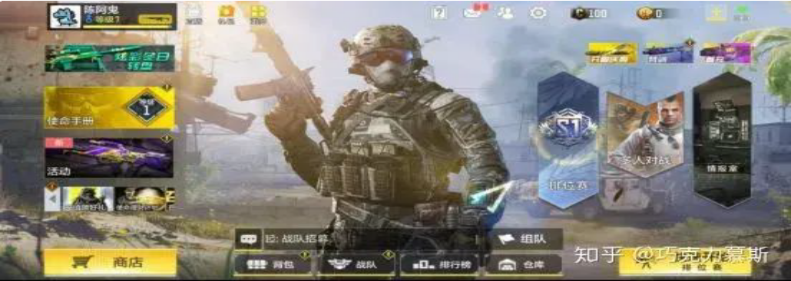

CODMCN UI in 2020, thanks to zhihu@巧克力慕斯

But three years later, cause of adding lots of functions, the homepage changed complex.

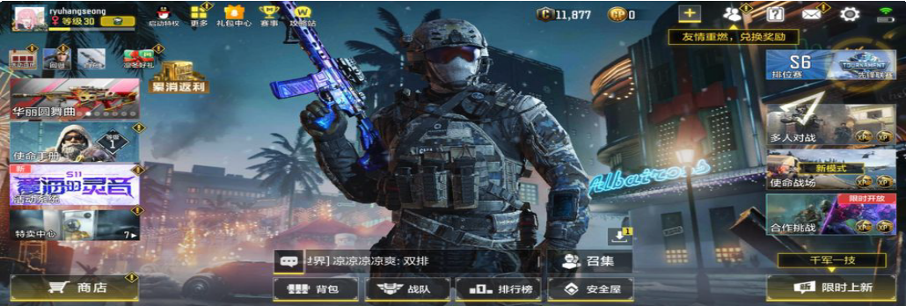

CODMCN UI in 2023

In order to improve players' immersion and operational convenience, developers have added a lot of functions and information to the homepage, such as mode select, activity diary, etc. Also, in order to keep players informed of the latest developments and changes in the game, the developer has released many new news prompts on the homepage. Obviously, with many of activities and modes added, the homepage is changed too complex for too many buttons. Except the character’s model, all the places has covered buttons.

# Homepage Optimization

## Current status

Planned

## Aim of design

Now the homepage composing is complex, displayed too many elements, need optimization.

## Main requirements

Program requirements

The designer need a tool can configuration the homepage button tool, there’s requirements need include:

* 1. Flexible configuration of text (including formats, etc.)
  2. Free to control a button’s survive time (accurate to minutes)
  3. Flexible configuration of texture
  4. Flexible configuration of where extra icons can display overlap the button
  5. Free to control what page will the button jump to UIUX requirements

The player need a simple homepage, changed base on the origin homepage (2023 ver.), there’s requirements need include:

1. A new homepage layout
2. A button can collect all the rewards from everywhere by one-click
3. A new downloading page in settings

## Detail requirements

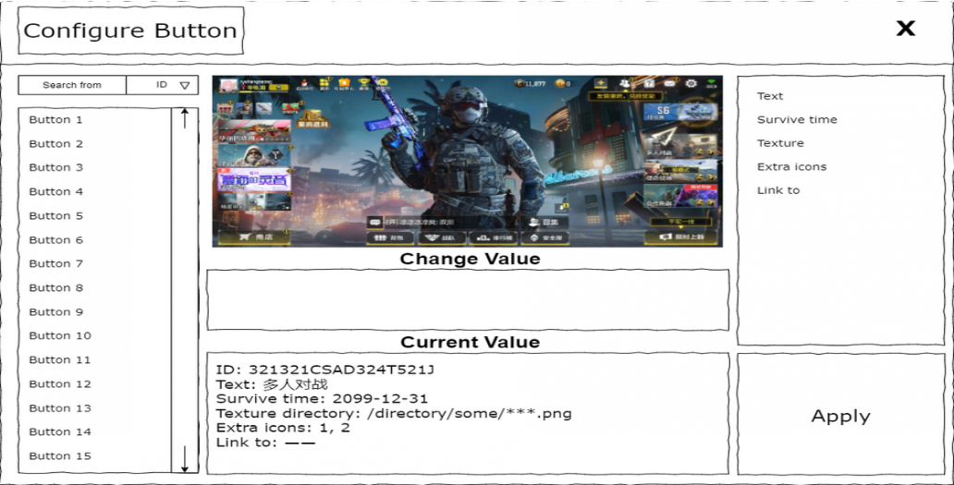

Program requirements

1. Flexible configure button’s attributes (like text, survive time, texture, extra icons, link to, etc.)
2. Text: It will change the displayed text on the button. It’s value is a directory.
3. Survive time: It will change what time will the button disappeared. It’s value is a time.
4. Texture: It will change the button’s texture. It’s value is a directory.
5. For extra icons:

“1” means Weapon Level Plus actived. “2” means Character Level PLus actived.

1. For link to:

“——” means clicks it will jump to another script, should not change here. If it’s a activity button, input URL string in it.

1. A search bar to find the button design want to change. (condition could be id, text, etc.)
2. Support changing button real time in the program.
3. After clicked “apply”, all the changes will integrated into only one changelist.

UIUX requirements

1. New homepage



old homepage’s layout

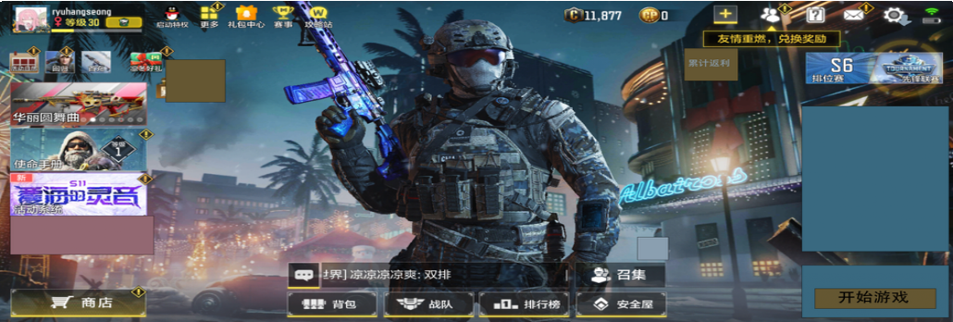

new homepage’s layout

“累计返利“ changed location from left to right, behind the charge. “特卖中心“ removed. Instead, player can find it in shop.

The downloading icon removed. Instead, when player downloading resources, the settings icon will display a downloading icon. Hide the “多人对战“, “使命战场“, “合作挑战“, and “限时上新“. On “限时上新“'s position, replace with “开始游戏“.

1. After clicked the “开始游戏“, the “多人对战“, “使命战场“ and “合作挑战“ displayed on old position.

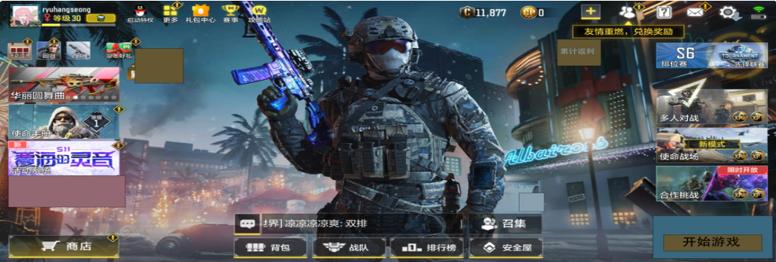

clicked “开始游戏“

1. Move the download page to settings.

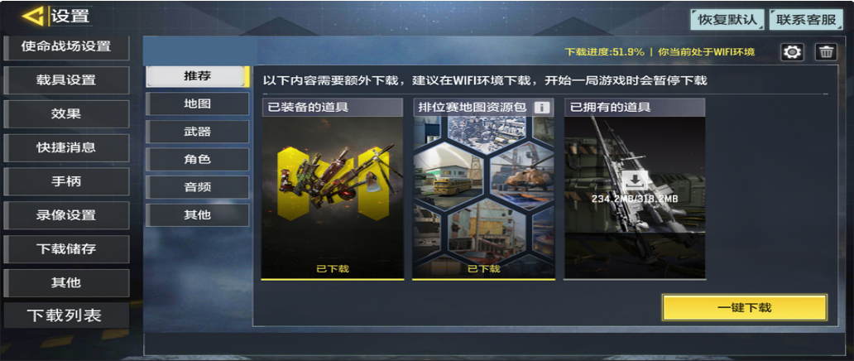

new settings

Add a “下载列表“ to settings.

1. Add a button one-click to activity system.

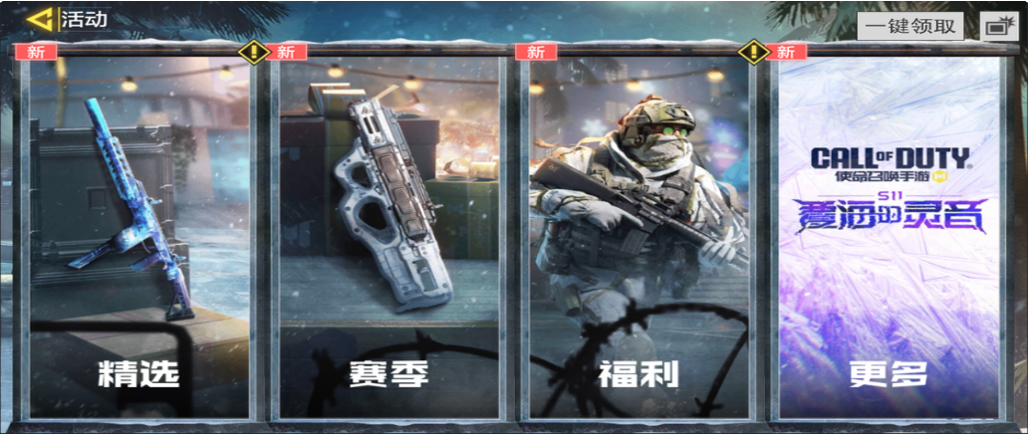

add a “一键领取“

This button will make player receives all the rewards in activity.